Universty Network Design

Session: 2024 – 2028

Submitted by:
Ahmad Hassan Tanseel 2024-CS-811
Supervised by:
Mr. Muhammad Tahir

Subject :
Computer Networks (CS-203)

Department of Computer Science
University of Engineering and Technology, Lahore
Pakistan.

University Network Design and Implementation Report

1. Introduction
This report presents the planning, design, implementation, and evaluation of the network infrastructure for University, which operates across two campuses located 20 miles apart. The university accommodates four faculties: Health and Sciences, Business, Engineering/Computing, and Art/Design. Both staff and students require reliable, secure, and scalable network connectivity with access to internal and external services.
The network was designed and implemented using Cisco Packet Tracer, following modern networking principles including VLAN segmentation, dynamic IP addressing, RIPv2 routing.

2. Network Planning and Design

2.1 Network Design Objectives
The main objectives of the proposed network design were:
- Logical separation of faculties and departments
- Secure and efficient communication between campuses
- Centralized routing and server management
- Scalability for future expansion
- High availability and ease of maintenance

2.2 Campus Overview

Main Campus
- Building A
  - Management Department
  - HR Department
  - Finance Department
  - Faculty of Business
- Building B
  - Faculty of Engineering & Computing
  - Faculty of Art & Design
- Building C
  - Student Computer Labs
  - IT Department
  - Internal Servers (Web, File, DNS, etc.)

Branch Campus
- Faculty of Health & Sciences
- Separate floors for staff and student labs

2.3 Logical Network Segmentation (VLAN Design)
Each department and faculty was placed on a separate VLAN and IP network to enhance:
- Security
- Broadcast control
- Network performance
VLAN | Department / Faculty
VLAN100 | Lab
VLAN 10 | Management
VLAN 20 | HR
VLAN 30 | Finance
VLAN 40 | Business
VLAN 50 | Engineering & Computing
VLAN 60 | Art & Design
VLAN 70 | Student Labs
VLAN 80 | IT Department
VLAN 90 | Health & Sciences

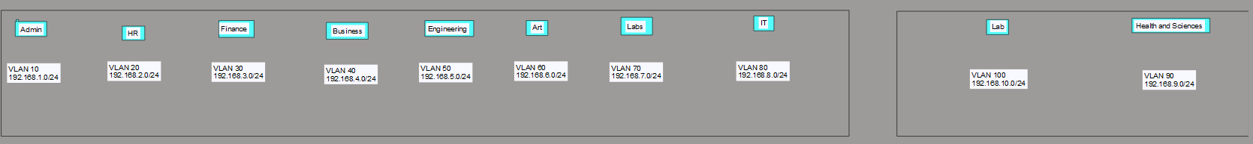

2.4 IP Addressing Scheme
A Class C private addressing scheme was used:
Example:
- 192.168.10.0/24 – Management
- 192.168.20.0/24 – HR
- 192.168.30.0/24 – Finance
- 192.168.40.0/24 – Business
- 192.168.50.0/24 – Engineering
- 192.168.60.0/24 – Art & Design
- 192.168.70.0/24 – Student Labs
- 192.168.80.0/24 – IT Department
- 192.168.90.0/24 – Health & Sciences

3. Network Configuration and Implementation

3.1 Network Topology Setup
The topology includes:
- Core routers at each campus
- Layer-2 switches for access
- Trunk links between switches
- WAN link connecting campuses
- External cloud-based email server

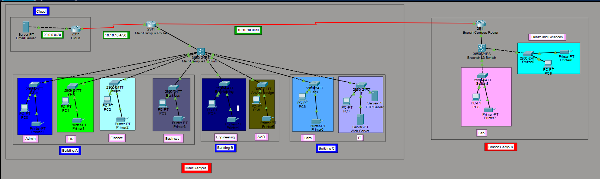

3.2 VLAN Configuration on Switches
Each switch was configured with:
- VLAN creation
- Access port assignment
- Trunk ports

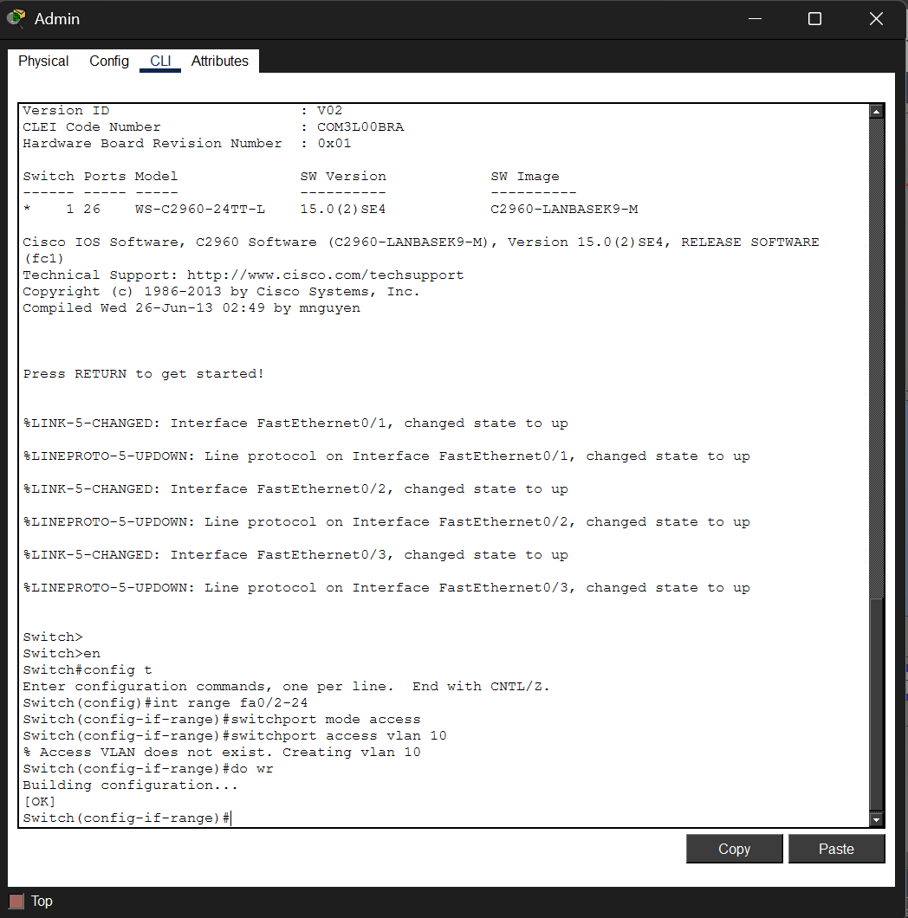

3.3 Inter-VLAN Routing
Router-on-a-Stick configuration was used:
- Sub-interfaces for each VLAN
- Encapsulation dot1Q
- Gateway IP for each VLAN

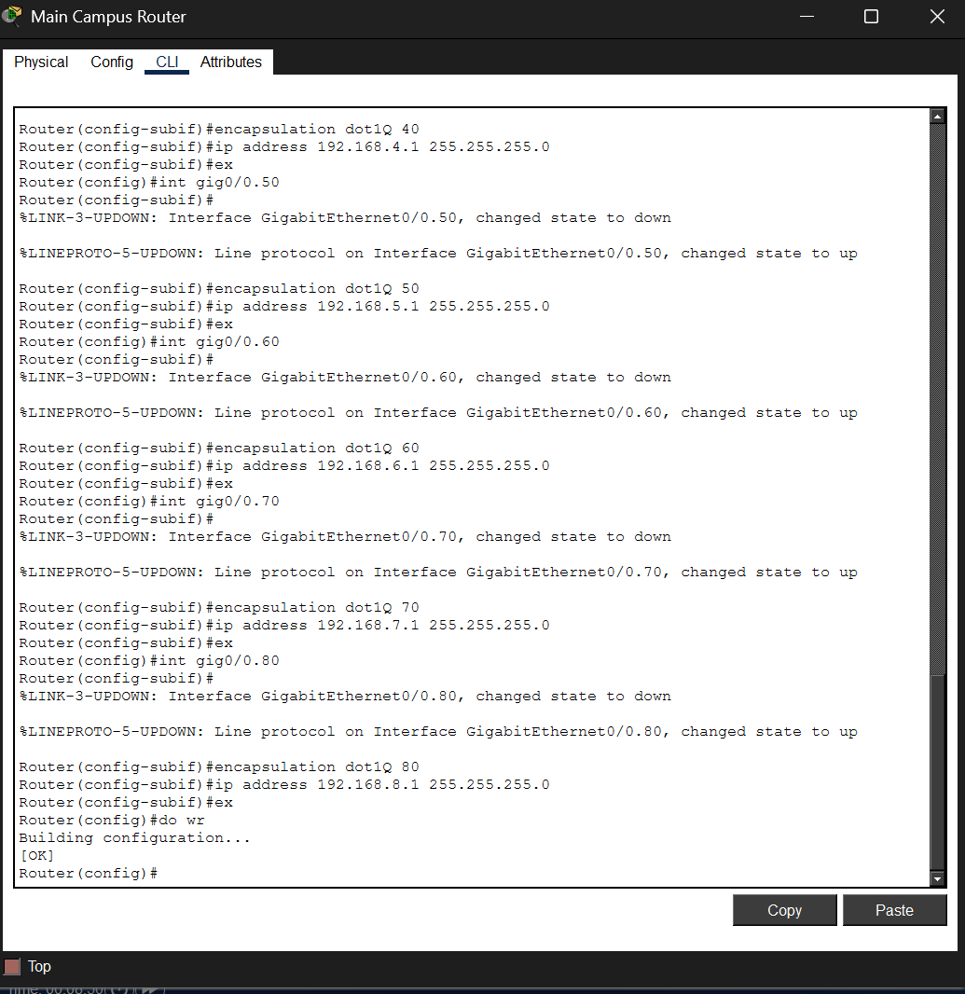

3.4 DHCP Configuration (Building A)
A router-based DHCP server was implemented to dynamically assign IP addresses to:
- Management
- HR
- Finance
- Business departments
DHCP pools were created for each VLAN with:
- Network address
- Default gateway
- DNS server

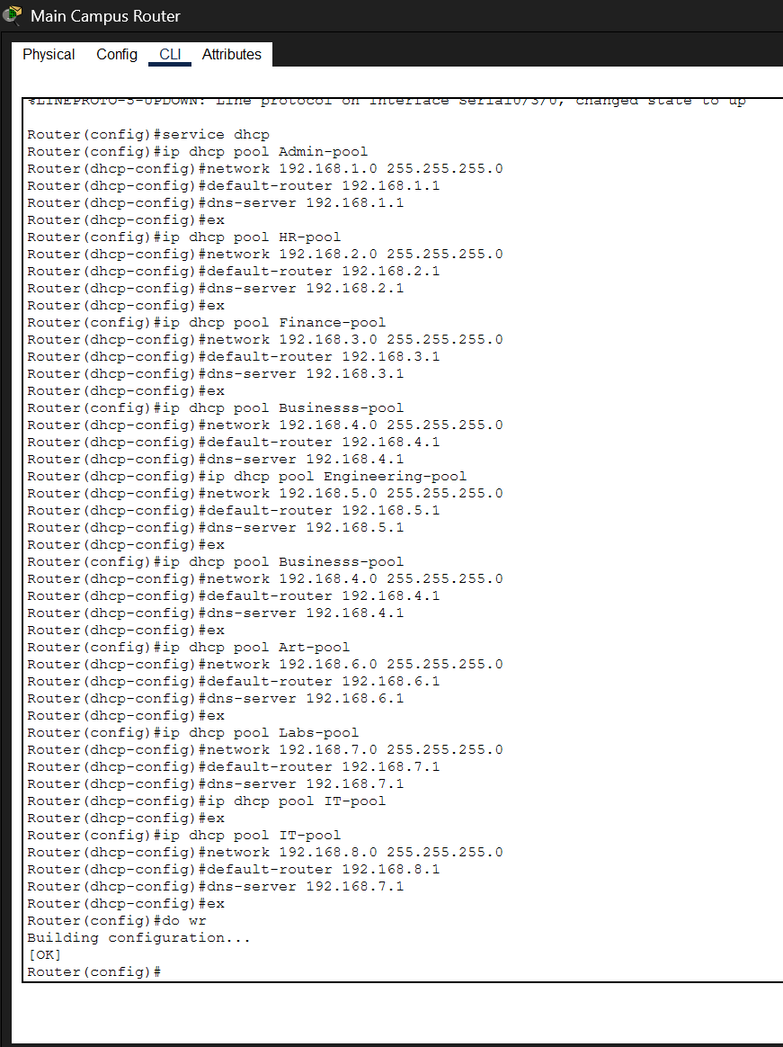

3.5 Routing Protocol Configuration
- RIPv2 was used for internal routing between routers
- Automatic route updates enabled
- Version 2 selected to support CIDR
- Static routing configured for the external email server

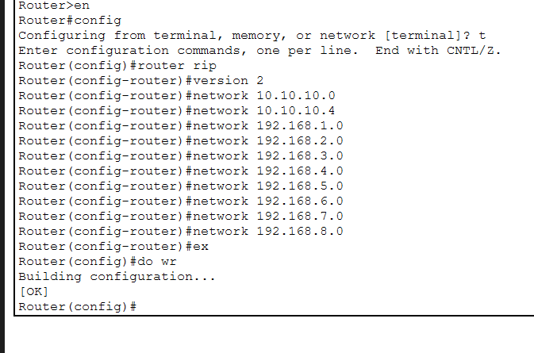

3.6 External Email Server (Cloud)
The email server is hosted externally:
- Static route configured on edge router
- Successful ICMP and application-level connectivity verified

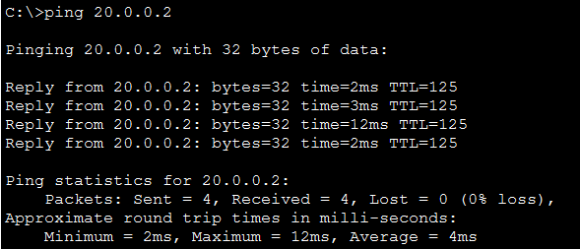

3.7 End-to-End Connectivity Testing
Connectivity tests performed:
- Ping between VLANs
- Access to internal web server
- Access to external email server
- DHCP verification

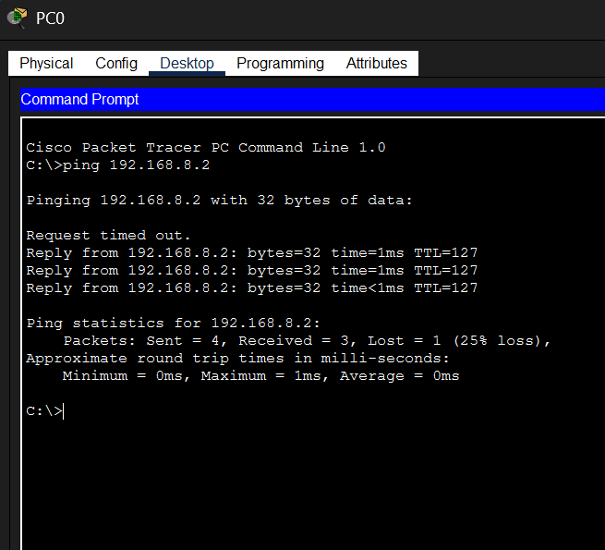

4. Evaluation and Critical Appraisal

4.1 Performance

The network demonstrates strong performance due to:
- VLAN-based broadcast reduction
- Efficient routing using RIPv2
- DHCP
Latency between campuses remains acceptable despite distance.

4.2 Scalability
The design is highly scalable:
- New departments can be added via VLANs
- IP addressing supports expansion
- Additional switches and routers can be integrated easily

4.3 Reliability
Reliability is ensured through:
- Structured hierarchical design
- Centralized IT management
- Dynamic routing adaptation

4.4 Security
Security measures include:
- VLAN isolation
- Limited broadcast domains
- Controlled routing paths
Further improvements could include:
- ACLs
- Firewall implementation
- Port security

5. Conclusion
This project successfully delivered a fully functional, secure, and scalable network for University. The use of VLANs, RIPv2, DHCP, and structured design ensures that both campuses can operate efficiently while meeting academic and administrative needs.The network satisfies all stated requirements and provides a strong foundation for future growth and enhancement.

6. References
- Cisco Networking Academy Documentation
- Cisco Packet Tracer User Guide
- Computer Networking Principle
- YouTube

